UNVEILING THE VIRTUAL CLASSROOM: AN IN-DEPTH ANALYSIS OF THE ONLINE EDUCATION SYSTEM

STEP BY STEP PROJECT DEVELOPMENT PROCEDURE

- Login to IBM Cognos Analytics webpage through google search
- Entered to my IBM page using user id and password.
- Dataset in csv format uploaded into the tool page using the upload option.
- Completed the preprocessing of data and uploaded into the data module and saved under my content section.
- For data visualization added my dataset into the data exploration and using
+create symbol created unique visualizations and saved.

Outputs generated through the above process for the in-depth analysis of online education system.

OUTPUT
Across all values of Gender - Your level of satisfaction in Online Education, the sum of Age(Years) is over twenty thousand.
Age(Years) ranges from almost 1500, when Gender - Your level of satisfaction in Online Education is Female|Bad, to over six thousand, when Gender - Your level of satisfaction in Online Education is Male|Average.
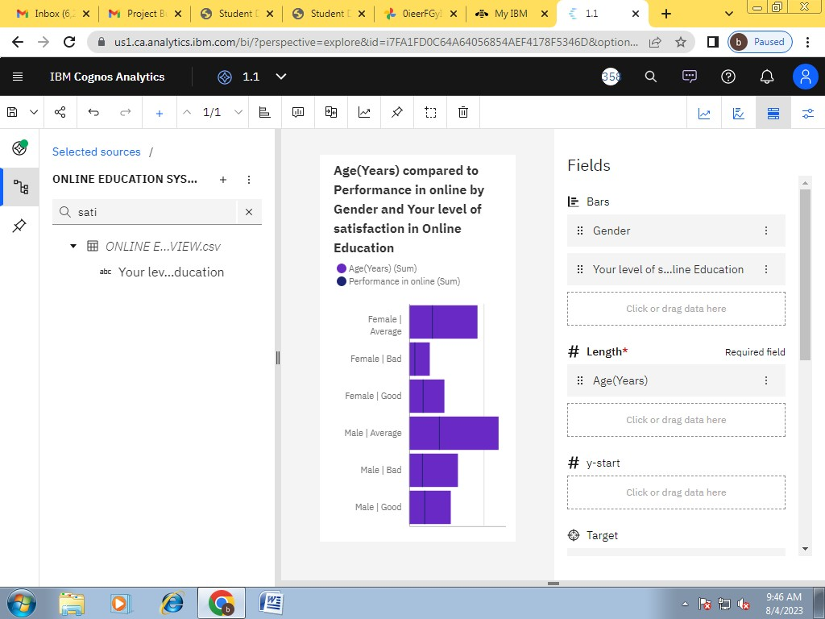

Across all values of Your level of satisfaction in Online Education, the sum of
Internet facility in your locality is over 3500.
Internet facility in your locality ranges from 823, when Your level of satisfaction in Online Education is Bad, to nearly two thousand, when Your level of satisfaction in Online Education is Average.
Internet facility in your locality is unusually high when Your level of satisfaction in Online Education is Average.
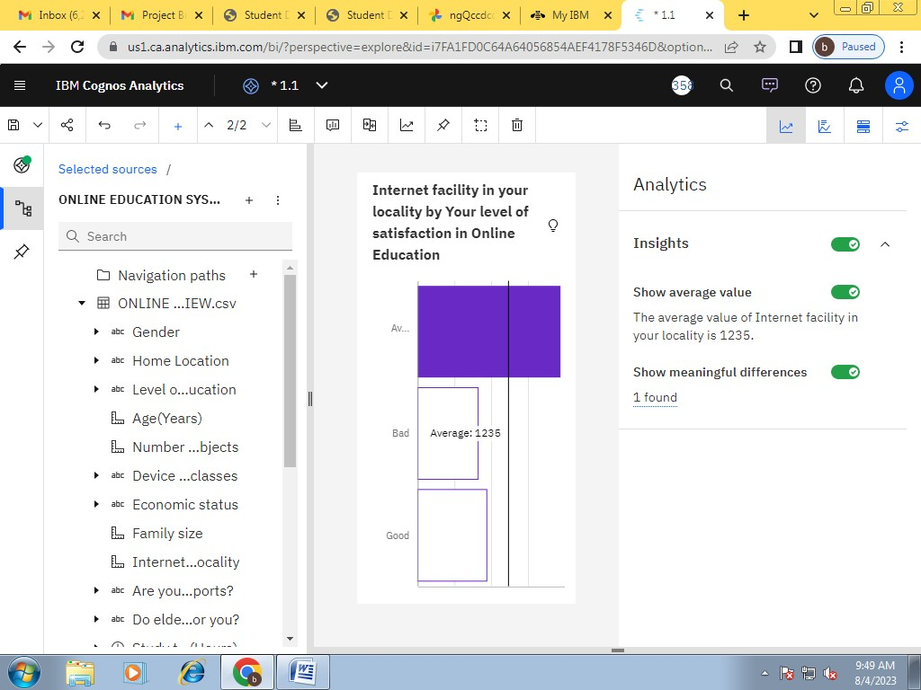

Over all values of Level of Education, the sum of Performance in online is nearly seven thousand.
Performance in online ranges from 562, when Level of Education is School, to nearly 5500, when Level of Education is Under Graduate.
Performance in online is unusually high when Level of Education is Under Graduate.
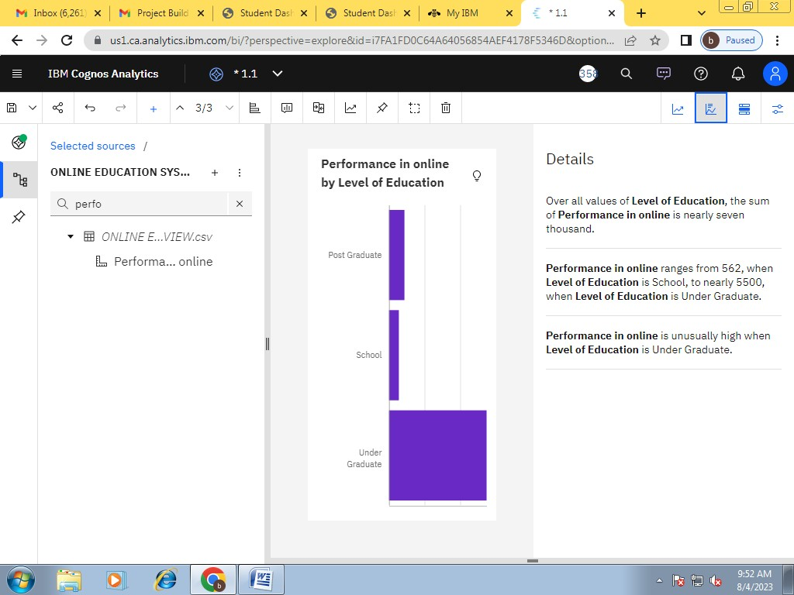

Across all device type used to attend classes, the sum of Time spent on social media (Hours) is over 2500.Time spent on social media (Hours) ranges from 71, when Device type used to attend classes is Desktop, to over 1500, when Device type used to attend classes is Laptop.Time spent on social media (Hours) is unusually high when Device type used to attend classes is Laptop.
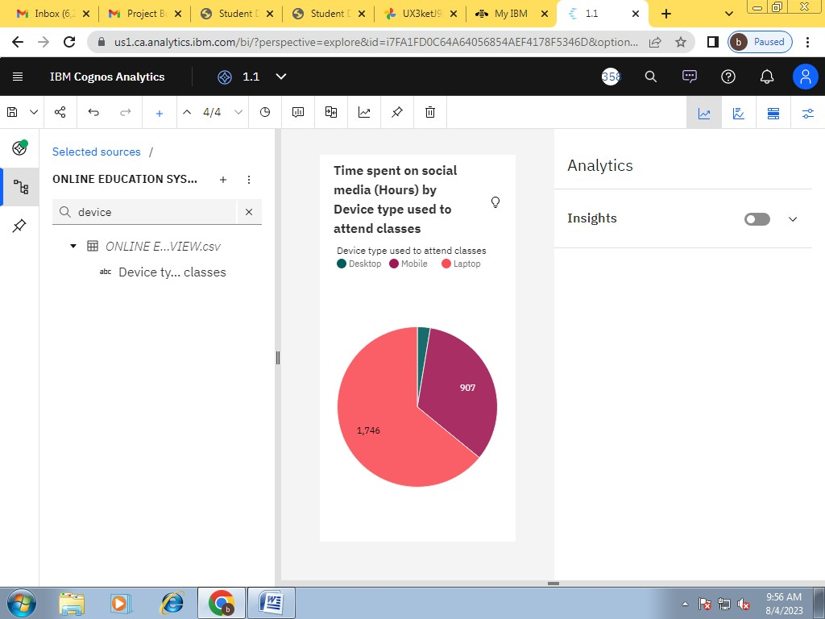

Over all values of Engaged in group studies? and Engaged in group studies?, the sum of Performance in online is nearly seven thousand.
The summed values of Performance in online range from nearly three thousand to over four thousand.
Performance in online is unusually high when the combination of Engaged in group studies? and Engaged in group studies? is No and No.
For Performance in online, the most signiﬁcant value of Engaged in group studies? is No, whose respective Performance in online values add up to over four thousand, or 58.1 % of the total.
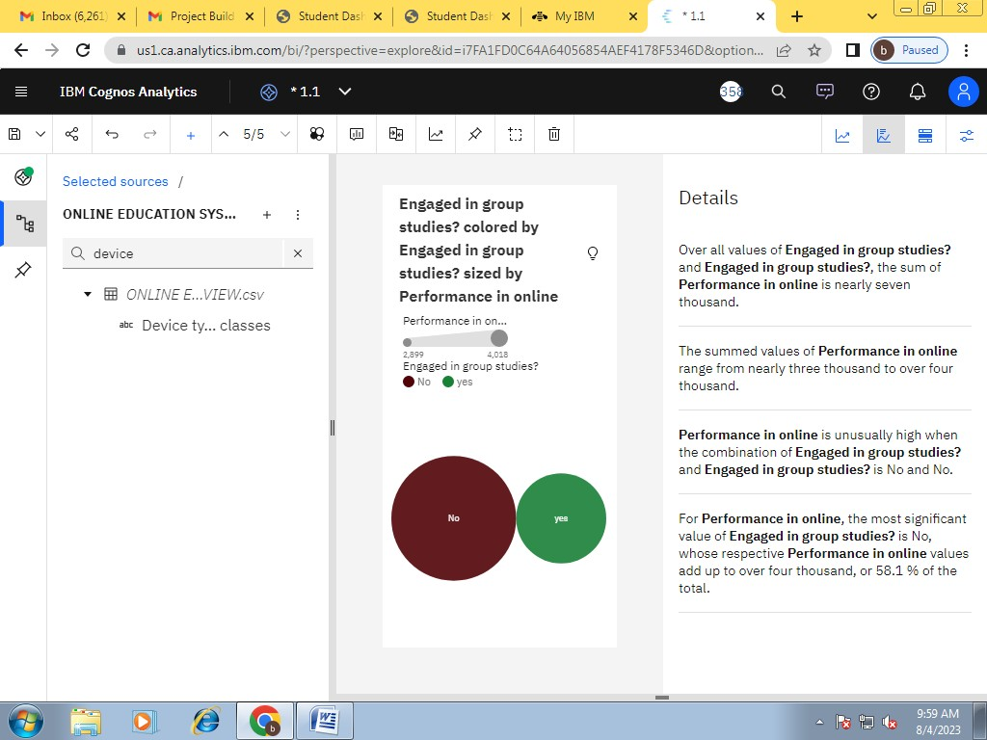

The total number of results for Average marks scored before pandemic in traditional classroom, across all average marks scored before pandemic in traditional
classrooms, is over a thousand.
The counts are unusually high when the values of Average marks scored before pandemic in traditional classroom are 81-90 and 71-80.
81-90 (33.2 %) and 71-80 (30.3 %) are the most frequently occurring categories of Average marks scored before pandemic in traditional classroom with a combined count of 656 items with Average marks scored before pandemic in traditional
classroom values (63.5 % of the total).
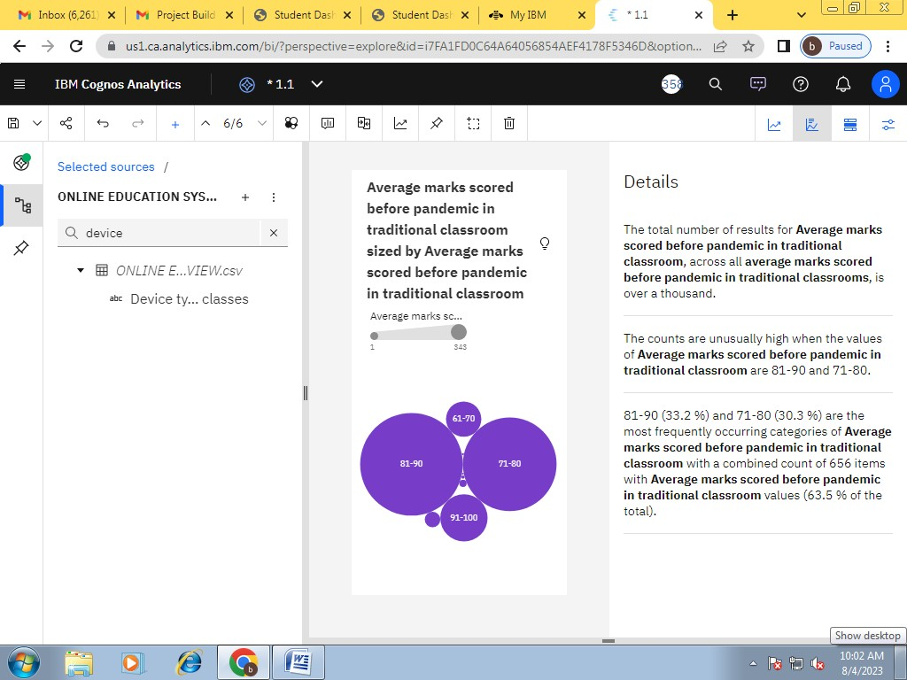
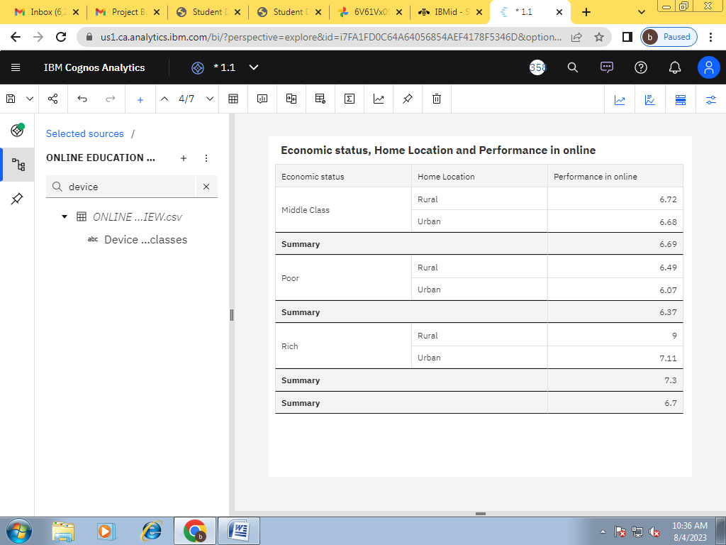

Over all values of Age(Years), the sum of Performance in online is nearly seven thousand.
Performance in online ranges from 4, when Age(Years) is 32, to over 1500, when
Age(Years) is 20.
Performance in online is unusually high when Age(Years) is 20, 19 and 18.
For Performance in online, the most signiﬁcant values of Age(Years) are 20, 19, and 18, whose respective Performance in online values add up to over 4500, or 67.6 % of the total.
